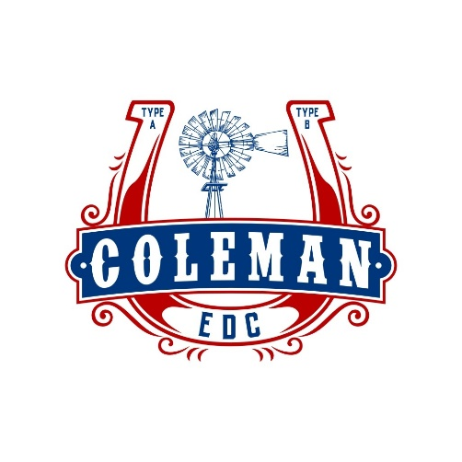

Façade Program Application
Fiscal Year 2023-2024

Coleman EDC
Coleman Economic Development Corporation
Coleman Community Coalition
200 W. Liveoak
Coleman, Texas 76834

Contact Director of Economic Development
325-625-3669 ext. 104
edc@cityofcolemantx.us

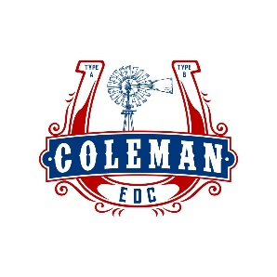
Façade Program Application (FY 2023-2024)
Step by Step Process:
Review Program Guidelines-Overview of the program, criteria and guidelines. The document can be found at: https://www.cityofcolemantx.us/edc
- Meet with EDC and City Staff-The applicant should meet with EDC and City Staff to discuss the project.
- Submit the Completed Application with Plans/Drawings-The Incomplete applications will be pushed to the following meeting. It is recommended that applicants work closely with EDC staff to ensure the application is complete prior to submission.
- Present to EDC Boards-EDC and City Staff will review and may:
Recommend
Not Recommend
Recommend with conditions (if approved with conditions the committee may request that the applicant make specific changes to the proposed improvements).
- Funds Awarded-If the project is awarded funds, a final scope of work must be provided, and the applicant will be required to sign a form agreeing to carry out the work as described and provide a W-9 form with federal ID# or SSN# for the sole proprietorship, corporation, or partnership.
- Acquire Planning and Building Permits-Building, planning, and other permits must be acquired before construction is initiated.
- Complete Work and Submit for Reimbursement-After the work is completed, the applicant must provide proof of payment, invoices and other documentation when filing for reimbursement. A final inspection of the project must be done prior to reimbursement.

2
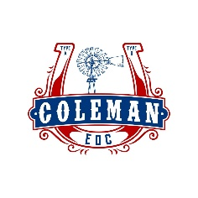
Façade Program Application (FY 2023-2024)
Application Checklist
The application must include the following information:

____ Completed Information sheet and Signature Page
Include property owner/owners’ signature/signatures, if the applicant is not also the owner.

____ Scope of Work
Complete the scope of work for the project. It must include:
Itemized list of all proposed improvements
Description of all proposed improvements
(including materials and color choices)
Estimated cost for improvements
Use the template included in the application (see page 6 for an example)

____ Bid Estimates
A written bid from the contractor/contractors or a written estimate of material if the applicant will be doing the work.

____ Concept of the project
Please illustrate the proposed façade improvement and include drawings, photos or some type of example of the changes that are being proposed.

____ Proposed Materials (Samples if possible)
Please include sample photos of fixtures, lighting, awnings fabric or materials to be used.

Submit Completed Application to:
EDC, 200 W. Liveoak, Coleman, Texas, 76834

3
Façade Program Application (FY 2023-2024)
Project Information/Signature Page
____ Owner ____ Tenant $_________Amount Requested

Applicant Information:
__________________________________
Name
__________________________________
Business Name

_____________________________________________
Physical Address

______________________________________________
Mailing Address

______________________________________________
City, State/Zip Code

______________________________________________
Email

_______________________________________________
Phone

_______________________________________ ________________________________
Print Applicant Name Date Print Property Owner Name Date
(if applicant is not also owner)

_____________________________ ________________________
Applicant Signature Date Property Owner Signature Date
(if applicant is not also owner)

4
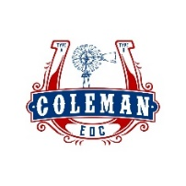
Scope of Work Template
Property Address:
Property Owner Name:
Business Name:

Improvement | Description of Work | Estimated Cost
TOTAL

5
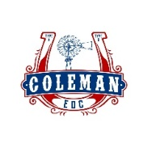

EXAMPLE-Scope of Work Template
Property Address: 000 New Town Lane
Property Owner Name: Joe Doe
Business Name: XYZ Retail

Improvement | Description of Work | Estimated Cost
Paint front of Building | Flat Paint (2 coats) Gray  Gloss Paint (2 coats) White | $2,000
Replace Awning | Fabric and Frame with new cloth | $6,000
TOTAL |  | $8,000

6

